

**Faculty of engineering - Shoubra**

**Benha University**

|  |  |  |  |
| --- | --- | --- | --- |
|  | Name | Edu mail | B.N |
| 1 | **عبدالله سمير عبدالرحمن علي** | **abdallah1955480@feng.bu.edu.eg** | **491** |

**TOBIC: Artificial intelligence**

* **Application Brief:**

I chose to write about artificial intelligence because Artificial intelligence is one of the main pillars on which the technology industry is based today. Artificial intelligence can be defined as the ability of machines and digital computers to carry out specific tasks that mimic and are similar to those of intelligent beings; Such as the ability to think or learn from previous experiences or other processes that require mental processes, as artificial intelligence aims to reach systems that enjoy intelligence and behave in the way that people behave in terms of learning and understanding, so that these systems provide to their users various services of education and guidance Interaction, etc

* SCREEN *SHOTS:*

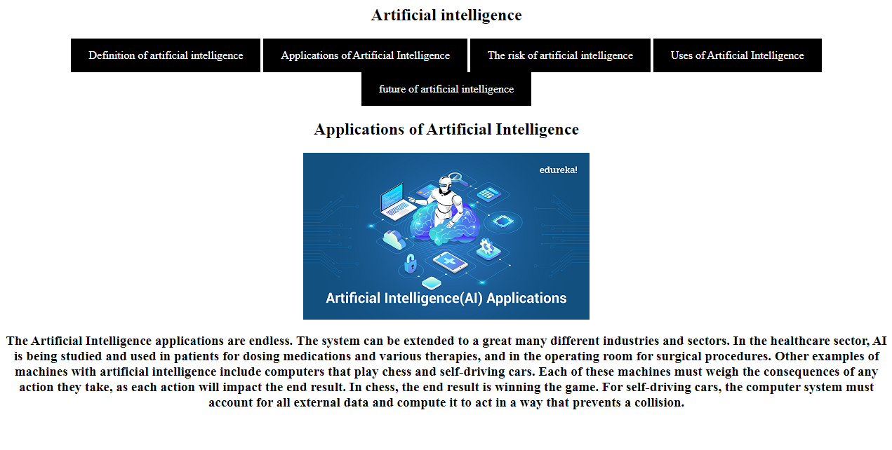

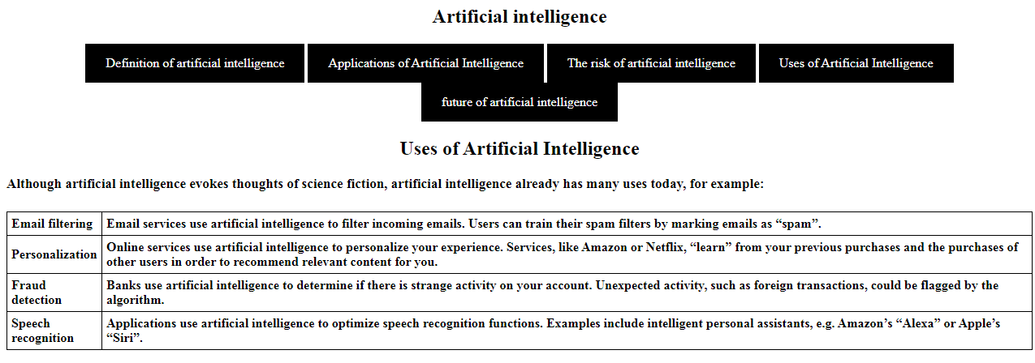

* **Resource code :**





